May 1st 2026 to May 2nd 2026
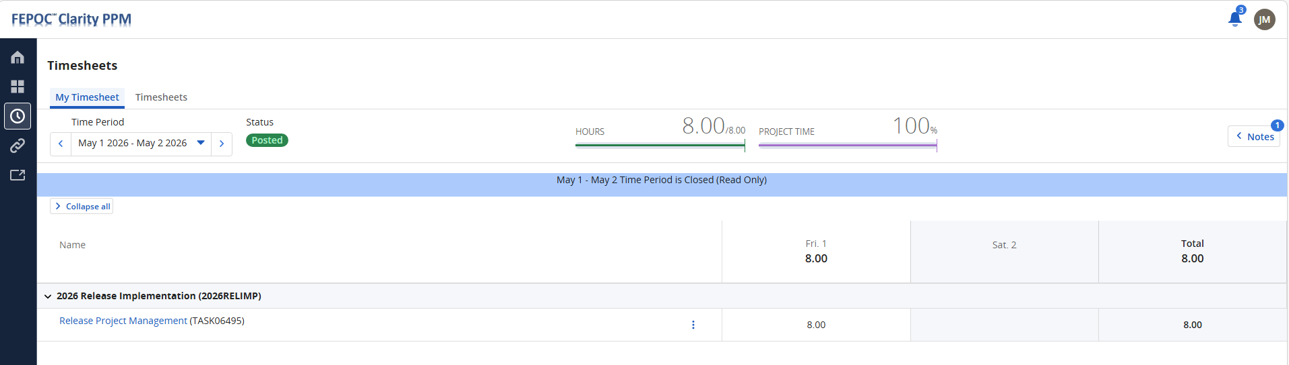

May 3rd 2026 to May 9th 2026

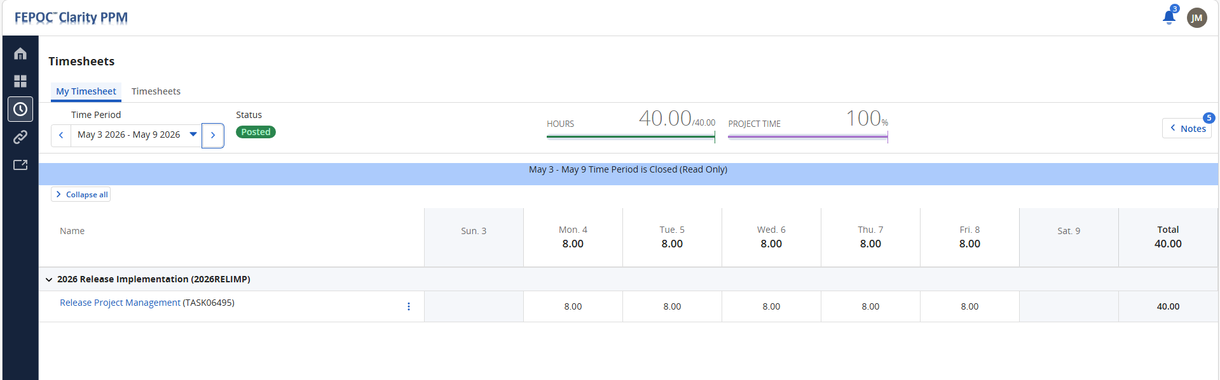

May 10th 2026 to May 16th 2026

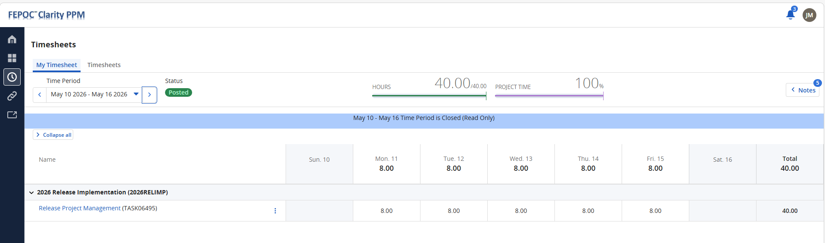

May 17th 2026 to May 23rd 2026

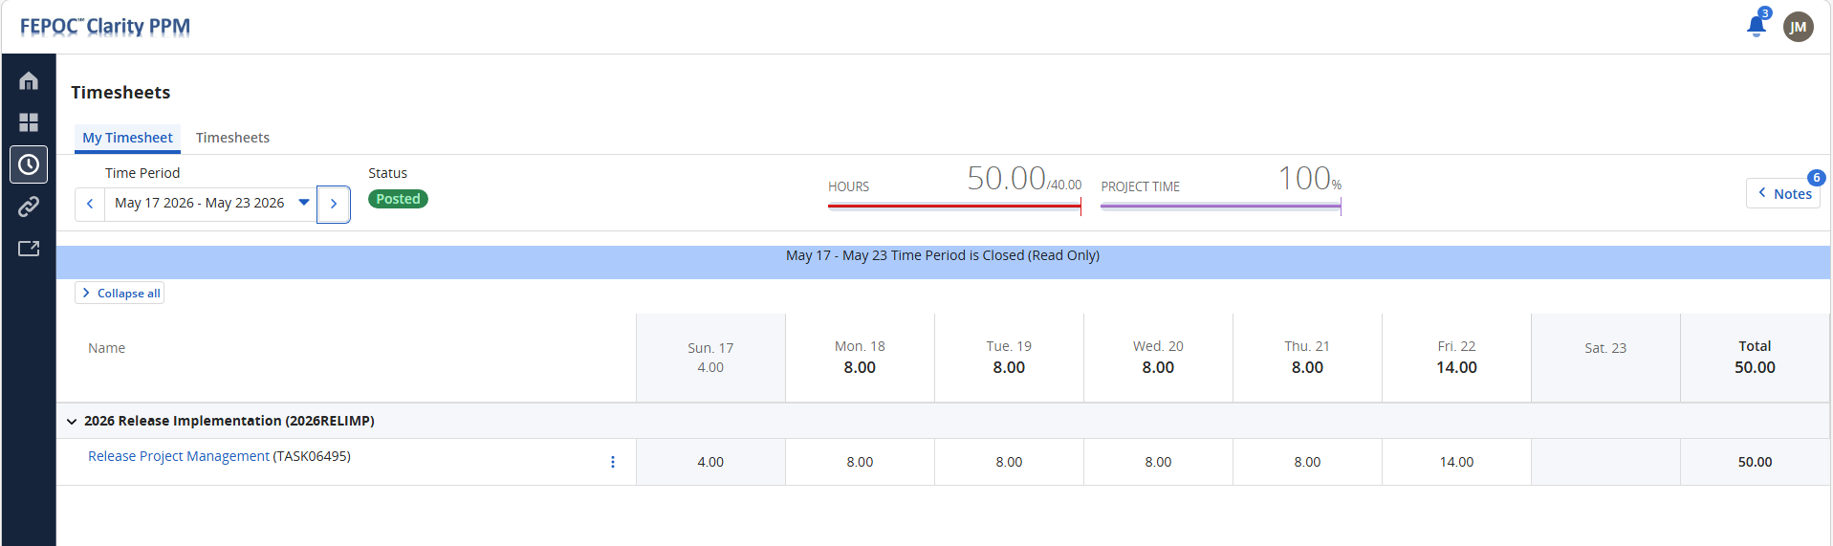

May 24th 2026 to May 30th 2026
